“AWARENESS ON ORGANIC FARMING”


COMMUNITY SERVICE PROJECT
A Project report submitted in partial fulfillment for the award of the degree of
BATCHELOR OF TECHNOLOGY
IN

ELECTRONICS AND COMMUNICATION ENGINEERING
Submitted by
JAMPALA THARUN KUMAR(222H1A0478)
Under the esteemed guidance of
Mrs.K.GAYATHRI,M.Tech
Assistant Professor
DEPARTMENT OF ELECTRONICS AND COMMUNICATION ENGINEERING

AUDISANKARA INSTITUTE OF TECHNOLOGY
An Autonomous Institute affiliated to JNTUA,Ananthapuram,Accredited by NAAC with A Grade
(AUTONOMOUS)
NH-5 Bypass Road, Gudur-524101, Tirupati (DT)
www.audisankara.ac.in
2022-2026
An Autonomous Institute affiliated to JNTUA,Ananthapuram,Accredited by NAAC with A Grade
(AUTONOMOUS)

NH-5 Bypass Road, Gudur-524101, Tirupati (DT) www.audisankara.ac.in

DEPARTMENT OF ELECTRONICS AND COMMUNICATION ENGINEERING


CERTIFICATE
This is to certify that the Community Service Project report entitled
“AWARENESS ON ORGANIC FARMING " is the bonafide work done by JAMPALA THARUN KUMAR(222H1A0478) in partial fulfillment of the requirements for the award of the degree of Bachelor of Technology in Electronics and Communication Engineering, from Jawaharlal Nehru Technological University Anantapur, Anantapuram, during the year 2022-2026.

PROJECT GUIDE CSP INCHARGE  Mrs.K.Gayathri.M.TECH Mr.M.Prasad Rao M.TECH  Assistant professor Assistant professor  Department of ECE Department of ECE  ASCET, GUDUR ASCET, GUDUR  Submitted for the viva-voce examination held on: | HEAD OF THE DEPARTMENT  Prof.J.Amerendra MTech.,(Ph.D).  Associate Professor  Department of ECE  ASCET, GUDUR
Internal Examiner | External Examiner

An Autonomous Institute affiliated to JNTUA,Ananthapuram,Accredited by NAAC with A Grade
(AUTONOMOUS)

NH-5 Bypass Road, Gudur-524101, Tirupati (DT) www.audisankara.ac.in

DEPARTMENT OF ELECTRONICS AND COMMUNICATION ENGINEERING

DECLARATION

I, am JAMPALA THARUN KUMAR (222H1A0478) hereby declare that the Community
Service Project entitled “AWARENESS ON ORGANIC FARMING’ Work done under the esteemed guidance of Mrs.K.Gayathri.Assistant professor , Department of ECE and is submitted in partial fulfillment of the requirements for the award of the Bachelor degree in ECE.

Date:
Place:NAIDUPETA

An Autonomous Institute affiliated to JNTUA,Ananthapuram,Accredited by NAAC with A Grade
(AUTONOMOUS)

NH-5 Bypass Road, Gudur-524101, Tirupati (DT) www.audisankara.ac.in

CERTIFICATE FROM OFFICIAL OF THE COMMUNITY

This is to certify that JAMPALA THARUN KUMAR Reg. No 222H1A0478 of Audisankara College of Engineering and Technology underwent community service in NAIDUPETA(village),NAIDUPETA(Mandal),TIRUPATI(district) from 15-08-2024 to 14-10-2024. The overall performance of the Community Service Volunteer during his/her community service is found to be Satisfactory.

Authorized Signatory with Date and Seal

An Autonomous Institute affiliated to JNTUA,Ananthapuram,Accredited by NAAC with A Grade
(AUTONOMOUS)
ACKNOWLEDGEMENT

The satisfaction and elation that accompany the successful completion of any task would be incomplete without the mention of the people who have made it a possibility. It is our great privilege to express our gratitude and respect to all those who have guided me and inspired me during the course of this community service project work.

First and foremost, I express my sincere gratitude and thanks to our honorable chairman
Dr. VANKI PENCHALAIAH, _{M.A., M.L., Ph.D} who provided all facilities and necessary encouragement during the course of study

I extend my gratitude and sincere thanks to our beloved Director (Eng) and Principal Dr. A. RAJA MURUGADOSS, _{Ph.D.,} for motivating and providing necessary infrastructure and permitting me to complete the project.

I would like to express the sense of gratitude towards our Head of the Department Prof.
J.Amarendra,_{M. Tech, (Ph.D.),} and Community Service project in charge Mr. M.Prasad Rao M.Tech and our internal guide Mr.class incharge name designation for their support and encouragement for completion of this project.

Finally, I express my sincere thanks to my parents all the teaching and non-teaching staff who guided and helped us to complete the project work successful.

ABSTRACT

0rganic farming relies on the integration of a diversity of farm components, the cycling of nutrients and other resources, and stewardship of soil and environment. This article discusses
the global history of the organic movement and its international origins, the role of organic
certification, global trends in sales and production of organic foods, the underlying principles and practices of organic farming, and current research on the production, economic, environmental, and social sustainability of organic farming. Organic farming is one of a number of innovative farming systems that can play a significant Role in future global food and ecosystem security.

Organic Amendments:
Organic farming reduces N2O emission as mineral N is not used as fertilizer, and the soils in organic farming are more aerated and have lower concentrations of mobile NO3−. Since organic crop systems are limited by the availability of N, their emissions are lower than those of conventional farming systems per unit of land area. However, with lower yield from organic farming, the emissions per unit of produce could be the same or higher (Petersen et al., 2006). A diversified crop rotation with green manure in organic farming improves soil structure and diminishes emission of N2O, even though the N provided by the green manure does contribute to N2O emissions. Thus, the substitution of urea by organic sources can be a good management strategy to reduce N2O emission from soils. Organic farming has been found to be practiced in most of the study countries to varying degrees. In Bhutan, it is practiced as a pillar of the green economy and is integral to carbon-neutral development policies. Farming in Bhutan has been largely a subsistence system, utilizing limited or minimal quantities of inorganic inputs. Currently, major crops under organic production are sweet buck wheat, herbs, and vegetables. Fruit crops are grown free of chemicals or with minimal use of inorganic inputs under organic farming regimes. The pest management strategies practiced include pheromone traps and bait traps for fruit flies and similar crop pests.

Index

S.No | Topics | Page numbers
1. | Introduction to community service defining  Need/importance  Forms of community service  Way to participate in community | 2  3  4  5
2. | Activities conducted
 | CHAPTER 1: EXECUTIVE SUMMARY | 12-13
 | CHAPTER 2: OVERVIEW OF THE COMMUNITY | 14
 | CHAPTER 3: COMMUNITY SERVICE PART | 15
 | - OBJECTIVES OF THE RESEARCH  - METHODOLOGY | 16-21
 | CHAPTER 4: ACTIVITY LOGS &WEEKLY REPORTS | 22-31
 |   WEEKLY CAMPAIGN PICTURES | 32
 | CHAPTER 5: OUTCOMES DESCRIPTION | 33
 |   PROBLEMS IDENTIFIED IN THE  COMMUNITY | 34
 |   ACTION PLANS FOR THE PROBLEMS  IDENTIFIED | 35
 |  REPORT OF THE MINI-PROJECT WORK  DONE | 36-40
 | CHAPTER 6: RECOMMENDATIONS AND  CONCLUSIONS | 41
 |  STUDENT SELF-EVALUATION | 42
 |  STUDENT SELF-EVALUATION | 43
3. | CHAPTER 7: PHOTOS AND VIDEOS LINK   REFERENCES | 44-46

4. | CHAPTER 8: CONCLUSION | 47

Introduction of Community Service
Defining Community service:

Community service is work done by a person or group of people that benefits others. It is often done near the area where you live, so your own community reaps the benefits of your work. You do not get paid to perform community service, though sometimes food and small gifts, like a t-shirt, are given to volunteers.
Community service can help any group of people in need: children, senior citizens, People with disabilities, English language learners, and more. It can also help animals, such as those at a shelter, and it can be used to improve places, such as Local Park, historic building, or scenic area as well. Community service is often organized through a local group, such as a place of worship, school, or non- profit organization. You can also start your own community service projects.
Background:
Community service is a non-paying job performed by one person or a group of people for the benefit of their community or its institutions. Community service is distinct from volunteering, since it is not always performed on a voluntary basis. It may be performed for a variety of reasons.
- It may be required by a government as a part of citizenship requirements, like the mandatory "Hand and hitch-up services" for some municipalities in Germany, or generally in lieu of military service or for civil conscription services.
- It may be required as a substitution of, or in addition to, other criminal justice sanctions–when performed for this reason it may also be referred to as community payback.
- It may be mandated by schools to meet the requirements of a class, such as in the case of service- learning or to meet the requirements of graduating as class valedictorian.

Need/Importance
Community Service Has a Number of Important Benefits Engaging in community service provides students with the opportunity to become active members of their community and has lasting, positive impact on society at large. Community service or volunteerism enables students to acquire life skills and knowledge, as well as provide a service to those who need it most. These are some of the common benefits of participating in a community service program:

- Psychological benefits: Volunteering increases over all life satisfaction and helps you feel good about yourself because you are helping others. It can also help to decreases stress and ease depression.
- Social benefits: Volunteering engages students with the community, creates special bonds with the population being served, and increases social awareness and responsibility.
- Cognitive benefits: Volunteering helps students enhance their personal knowledge, grow from new experiences, and develop better interpersonal communication skills.
Participating in community service not only makes a difference to the organization and people being served, but also makes a difference to every student’s career prospects. Participating in community service activities helps to enhance student resumes by allowing students to obtain work-related skills prior to graduation, builds good references for employers in regards to community involvement, and provides a forum to network with future potential employers. It also helps students develop civic and social responsibility skills and become more aware of what their community needs.
You can also make a positive contribution to your community by earning an online degree in nursing, criminal justice or psychology. Contact us today for more information about our programs where you can learn how to help real people and leave a positive impact on the world.
Forms of community service
There are three types of community service and service-learning: direct, in-direct and advocacy. Once a community need is identified, the project activities that are developed will align with one or more of the types. Below are definitions and additional examples of each type of community service and service-learning
Direct:-You can develop direct service activities where students interact with the recipients of service or the physical environment they have targeted for improvement. You and your chapter can volunteer at a food kitchen to serve community members in need. Or perhaps you can work with your community senior center to create an adopt -a- grandparent program that lasts beyond FFA Week.
In-Direct:-If you don’t have the ability to come indirect contact with the beneficiaries of service, you can organize an indirect service activity where students channel resources to a problem but do not interact with those being served. This can include organizing a canned food drive to donate to a food pantry in a neighboring community or participating in a community beautification project.
Advocacy: -It is important to always be an advocate for the issues that inspire you. During advocacy service activities, students bring awareness to an issue and inspire others to act. Advocacy can also address the underlying causes of a social problem by attempting to influence policymakers or elected officials.

Ways to participate in community service
There are hundreds of ways to participate in community service, depending on the skills and interests. Some common community service examples include:
- Working with school children: Tutoring children after school, collecting school supplies to donate, planting a school garden.
- Working with senior citizens: Visiting residents of a retirement center, delivering meals to senior citizens, driving them to appointments.
- Improving the environment: Holding a recycling contest, planting trees, creating a new trail at a nature Centre.
- Helping low-income people: Passing out food at a soup kitchen, collecting used clothes to be donated, making first aid kits for homeless

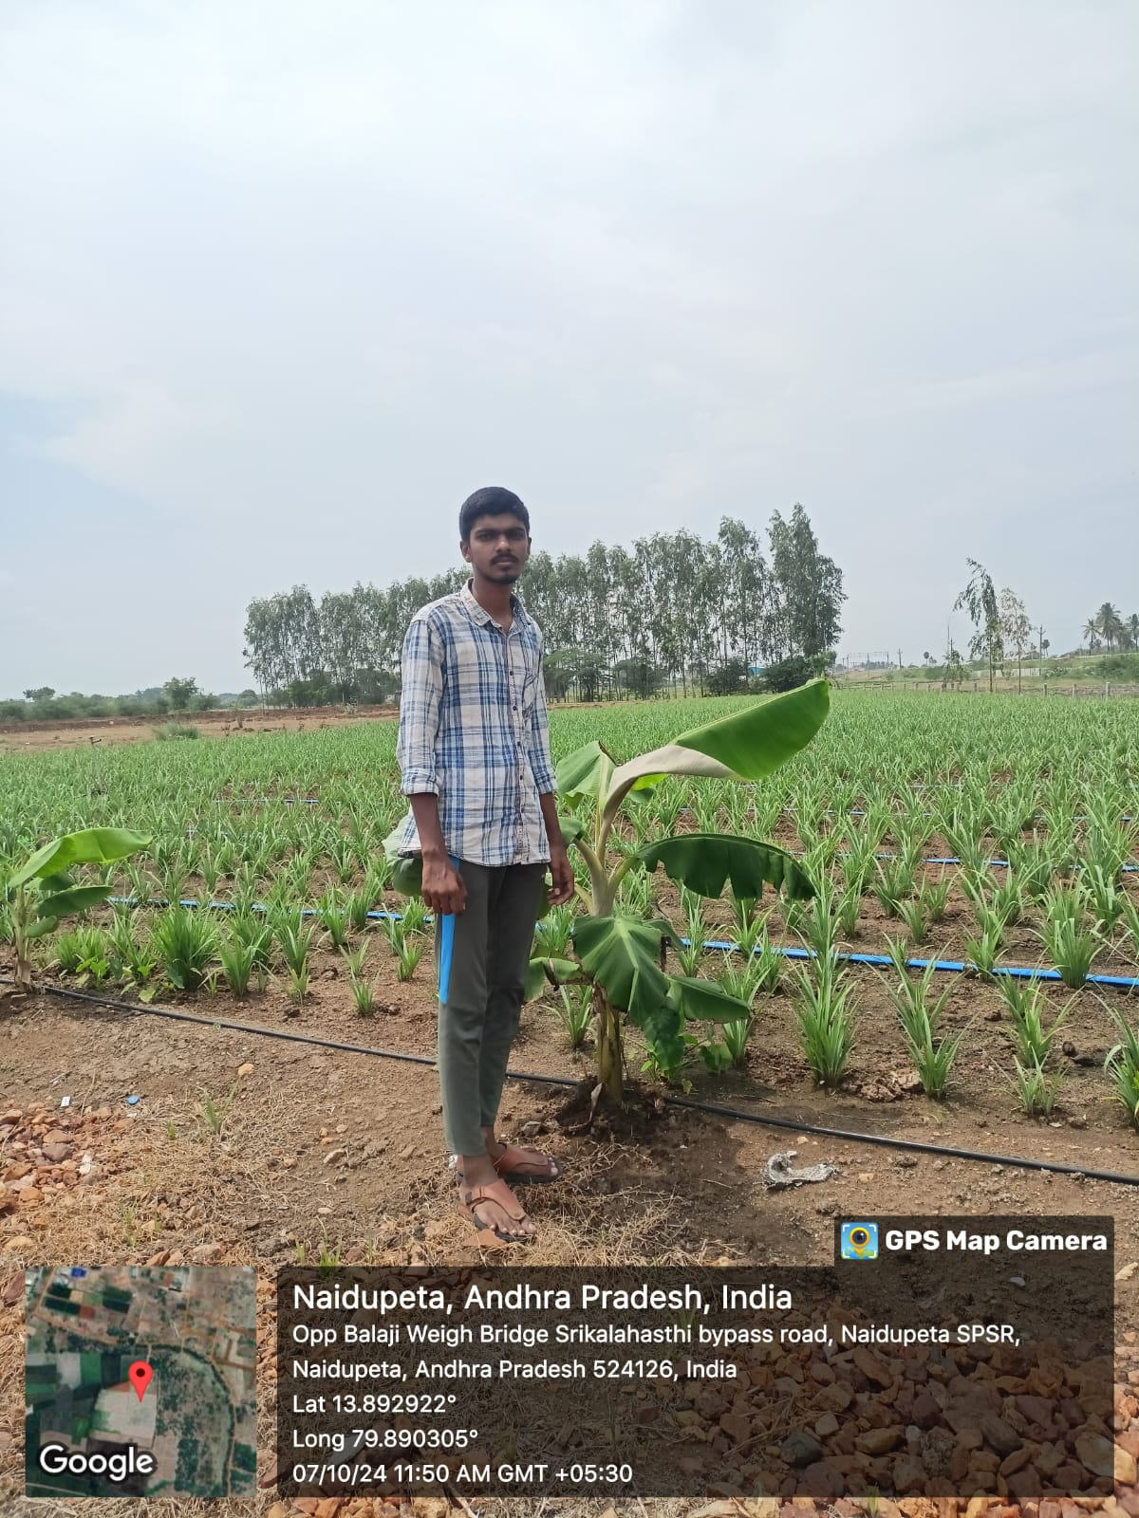

2.Activities Conducted:

CHAPTER1: EXECUTIVE SUMMARY

The community service report shall have only a one-page executive summary. It shall include a brief description of the Community and summary of all the activities done by the student in CSP and five or more learning objectives and outcomes.

Organic farming is an agricultural approach that emphasizes sustainable practices, biodiversity conservation, and the avoidance of synthetic inputs such as pesticides and genetically modified organisms (GMOs). This executive summary provides an overview of the key aspects, benefits, challenges, and future prospects of organic farming Definition of Organic Farming:
The chapter begins by defining organic farming as an agricultural approach that emphasizes the use of natural methods and materials to cultivate crops and raise livestock. It highlights the importance of avoiding synthetic inputs such as chemical fertilizers, pesticides, and genetically modified organisms
(GMOs).
Principles of Organic Farming:
The author discusses the fundamental principles that guide organic farming practices. These principles include promoting soil health and fertility, biodiversity conservation, minimizing environmental impact, and ensuring animal welfare. The chapter emphasizes that organic farming seeks to mimic natural ecological processes to create a sustainable and balanced agricultural system.
Historical Development:
A brief overview of the historical development of organic farming is provided. The chapter traces the origins of organic farming to early agricultural practices that relied on natural farming methods. It highlights the work of key individuals and organizations that contributed to the development of modern organic farming techniques.

Benefits of Organic Farming:
The author presents a comprehensive list of the benefits associated with organic farming. These include improved soil quality, reduced chemical contamination of food and the environment, enhanced biodiversity, and increased nutrient content in organic produce. The chapter also discusses how organic farming can contribute to rural development and provide economic opportunities for farmers.
Certification and Standards:
The chapter addresses the issue of organic certification and the establishment of standards to ensure the integrity of organic products. It explains the role of certification bodies and regulatory agencies in verifying that organic farmers adhere to specific guidelines and standards. The chapter emphasizes the importance of labeling and proper identification to enable consumers to make informed choices about organic products.
Challenges and Future Outlook:
The author acknowledges that organic farming faces various challenges, such as the higher cost of organic inputs and the limited availability of organic seeds. The chapter discusses ongoing research and initiatives aimed at addressing these challenges and further advancing organic farming practices. It concludes by expressing optimism about the future of organic farming and its potential to play a vital role in sustainable agriculture.

•  • | CHAPTER2: OVERVIEW OF THE COMMUNITY  About the Community/Village/Habitationincludinghistoricalprofile of the community / habita tion , community diversity , traditions , ethics and values.  Brief note on Socio-Economic conditions of the Community/Habitation  NELLORE is one of the 38 mandals in Nellore district in the state of ANDHRAPRADESH, INDIA.Its headquarters is Nellore. The vinjamoor village is located at vinjamoor mandal.  In this chapter, we will delve deeper into the concept of organic farming and explore its principles, methods, and benefits. Organic farming is an agricultural approach that emphasizes the use of natural and environmentally-friendly practices, aiming to produce healthy food while minimizing harm to the ecosystem. By adopting organic farming methods, communities can contribute to sustainable agriculture, promote biodiversity, and support the overall well-being of both people and the planet Key Topics Covered: Principles of Organic  Farming: a. Soil health and fertility management  - Ecological balance and biodiversity conservation  - Non-use of synthetic chemicals and genetically modified organisms (GMOs)  - Animal welfare and organic livestock management  - Sustainable resource utilization Organic Certification and Standards:  - Understanding the organic certification process  - Different organic certification bodies and their criteria  - Compliance with organic farming standards  14

CAPTER3: COMMUNITY SERVICE PART

DescriptionoftheActivitiesundertakenintheCommunityduringtheCommunityService
Project. This part could end by reflecting on what kind of values, life skills, and technical skills the student acquired.

Organic farming has engrossed much attention in current decades as a way to maintain farming production. At the same time, it has played an important role in dealing with the environmental harms rooted in traditional agricultural techniques. Organic farming not only produces fine and healthy food products but also improves the fertility and quality of soil (Isaacs2012). Function has described organic agriculture as: “Organic Agriculture is giving back to the environment what was taken from it” (Singh et al. 2012). Organic food is grown and processed without using any synthetic fertilizers or pesticides (insecticides, herbicides, and/or fungicides), plant growth regulators, such a short on s, live antibiotics G organisms, and human sewage sludg.

Biological pesticides produced from natural sources can be used in the production of organic food. Some preventative measures have to be applied prior to adopting the latest technologies for organic agriculture due to considerable risks of unpredictable tools such as genetic engineering (terminator al. 2012). Organic farming is based on ecological cycles, and procedures therefore diminish the use of exterior contributions.

As defined by Food and Agriculture Organization (FAO), “Organic farming is environmentally friendly ecosystem management in which use of all kinds of synthetic input is eliminated.” In March1999, organic agriculture was officially included into FAO’s agenda as a way to support sustainable progress. The interest of FAO in organic agriculture stems from its potential to contribute to rural development and global food security. FAO member countries in the International Conference on Organic Agriculture and Food Security in Rome emphasized the organic agriculture capability to create a more stable food supply, increased access to food in rural areas, and maintenance of natural resources .

ACTIVITY LOG FOR THE FIRST WEEK

DAY  &  DATE | BRIEF DESCRIPTION OF THE DAILY  ACTIVITY | LEARNING OUTCOME | Person  In-charge  Signature
Day– 1 | Based on the awareness of organic farming i was visited the farmers of  Vinjamoor(v),vinjamoor(m),AP(524228) | visiting the farmers of  Vinjamoor
Day-  2 | I explained them what is organic farming and its benefits | Benefits of organic farming
Day– 3 | I explained them what is dis advantages of non organic forming and its effects in future | Disadvantages of using chemicals
Day– 4 | I explained them what are the chemicals | Effects of chemicals
Day– 5 | Knowing what are the problems they are facing | Knowing what problems they are  facing
Day– 6 | I suggested the farmers of vinjamur based on their problems in natural manner | Conduct an awareness camp

WEEKLYREPORT WEEK–1(From Dt: 15/08/2024 to Dt :20/08/2024)

Objective of the Activity Done:
Detailed Report:
I reported the farmer of Vinjamoor, andhra pradesh(524228),in these village all the farmers are doing a
Non-organic farming. The most of the crop they are cultivated is Guava ,Chilli , Brinjal . These lands
having less fertility ,so they are using for the more production as chemicals. I explained them how to
increase the fertility using organic method and how to getting a benefits from organic forming
 By using the solid jeevamrutham and liquid jeevamrutham it will increase the soil fertility
And give proper nutrients to the plant for the growth
BENEFITS OF DOING ORGANIC FORMING
○ Healthy food and rich nutrients
○ Low investment and high profits
○ To lesser pollution and increase lifespan of fields
○ If we use chemicals in the land it will slowly complete damage the soil fertility and not used for

ACTIVITY LOG FOR THE SECOND WEEK

DAY  &  DATE | BRIEF DESCRIPTION OF THE  DAILY ACTIVITY | LEARNING  OUTCOME | Person  In-charge  Signature
Day– 1 | Based on the awareness of organic forming project i was visited the GM organic  forming | Visiting an GM Organic form
Day-  2 | I was collected the information from form manager to give awareness | Collecting the information
Day– 3 | Based on the collected information i prepared a chart or flexi | Preparing a plan or chart
Day– 4 | I was collected the information what are the bio chemicals used in forming | Knowing about chemicals and  its effects
Day– 5 | I visited the formers and knowing what problems they are facing | Visiting the farmers
Day– 6 | Suggested the farmers of vinjamoor based on their problems in natural manner | Conducting an awareness camp
WEEKLY REPORT WEEK–2(From Dt: 21/08/2024 to Dt: 28/08/2024)

Objective of the Activity Done:
Detailed Report:
I visited the GM organic farming Vinjamoor , Andhra pradesh The form only on manager,
Should told that they should cultivate only cucumber on organic method they can design a form
On 40 cents of land and maintain certain temperature based on the outside temperature.
They should use fertilizers and pesticides to cultivate that crop,chemical free farming is known as
Organic farming. They can plant more than 10,000 plants in 40 cents of land and the plants are planting on
Pots and spraying the pesticides using sprinkler. Fertilizers can be applied based on the plant growth

They are using nets to interweaving the plants and it is easy to harvest the crop. These cucumber crop will
come to harvest after 45 days the plant can be plantation
They should told that jeevamrutham and solid jeevamrutham to spray the insecticides and increase
The fertility in the soil. I prepared a flexi to give awareness to the farmers. Now-a-days chemical forming
Will increase 90% in the world wide it will damage the land future not will doing an agriculture,so I give
A suggestion to the farmers to avoid using dangerous chemicals in the fields doing an organic forming.

ACTIVITY LOG FOR THE THIRD WEEK
DAY  &  DATE | BRIEF DESCRIPTION OF THE DAILY  ACTIVITY | LEARNING OUTCOME | Person  In-charge  Signature
Day– 1 | On the awareness of organic forming I was visited  katepalli , AP(524228) | Visiting the farmers
Day-  2 | I explained how the organic farming will do and what  are the benefits of organic forming | Benefits of organic forming
Day– 3 | I explained how to increase the soil fertility and Decreasing insecticides | Improving soil fertility and decreasing dangerous insecticides
Day– 4 | How to make an organic bio chemical | Making an organic biochemicals
Day– 5 | Explain the difference between organic forming and non-organic forming | Difference between organic forming and non-organic forming
Day– 6 | Suggesting the farmers based on their problems | Conducting an awareness camp

WEEK–3(From D: 29/08/2024 to Dt: 05/09/2024)

Objective of the Activity Done:
Detailed Report:
I reported the farmers of vinjamoor(v), Vinjamoor(m),AP(524228) . At these village all farmers
are doing a non-organic farming and using high of chemicals to the crop for more production
○ I was explained them what effects of that high amount of using chemical
• Getting food infections to take that food
• It leads to decrease soil fertility
• It damages the soil not for cultivating other crops
• The crop production will be decrease yearly to yearly
 I was explained them what are the benefits of organic forming

The production of the crop should be healthy and nutritious

To develop the crop in the natural manner and maintain their growth

To lessen pollution, soil erosion, soil degradation

Using bio chemicals it will increase soil fertility and crop production
I was explained them to spray natural bio chemicals like liquid jeevamrutham and solid jeevamrutham
To increase the fertility and decrease the insecticides and the plant should growth healthy.

ACTIVITY LOG FOR FOURTH WEEK

DAY  &  DATE | BRIEF DESCRIPTION OF THE DAILY  ACTIVITY | LEARNING OUTCOME | Person  In-charge  Signature
Day–  1 | On the awareness of organic forming I was visited  NAIDUPETA farmers, , NAIDUPETA(m), AP(524126) | Visiting the farmers
Day-  2 | I explained how the organic farming will do and what are the benefits of organic forming | Explain the benefits on organic forming
Day–  3 | I explained to them what are the fertilizers should  Use and how much amount | Knowing about fertilizers
Day–  4 | I explained to them what are the pesticides should use and how much amount | About pesticides
Day–  5 | Knowing what problems they are facing on doing agriculture | Knowing their problems
Day–  6 | Suggesting the farmers of naidupeta based on their problems | Conducting awareness camp on organic farming

WEEKLY REPORT

WEEK–4(From Dt: 06/09/2024 to Dt: 17/09/2024)

Objective of the Activity Done:
Detailed Report:
I Reported to the farmers of vinjamoor(v) ,vinjamoor(m),AP(524228). I these village one of the
Former doing a lemon crop on organic forming. I collected some information from that farmer and
Knowing what problems they should face on that organic farming. I ask did you got benefit or not

He told that it is a one time investment method at the time of plantation only.

We keep no investment for chemicals all are available in naturally.

The crop production should be less but these crop have much demand in markets.
I went and meet others farmers in that village and I explain what are benefits and disadvantages of organic
Forming. I should told to the farmers using of high amount of chemicals it will damage soil.
 I explained them how to increase soil fertility natural manner

Take a cow wastage of required amount

Take some water as required of the cow wastage

Add jaggary of required amount in that water

Take a powder of Bengal gram and mix it into the jaggary water

Add a chemical free soil (puttamunu) with large amount as we required

Mix the all ingridients and make a round shape and stored them in a closed place
After three days we use it n the fields to increase fertility of soil


ACTIVITY LOG FOR THE FIFTH WEEK
DAY  &  DATE | BRIEF DESCRIPTION OF THE DAILY  ACTIVITY | LEARNING OUTCOME | Person  In-charge  Signature
Day–  1 | On the awareness of organic farming project  I was visited nandipadu farmers,vinjamoor(m) ,AP(524228) | Visiting the farmer
Day–  2 | Getting the information what problems they are facing | About the problems
Day– 3 | What are the different pesticides used for different crop | Knowing what problems they face
Day– 4 | What are fertilizers used for different crops | Suggesting them which fertilizers they should use
Day– 5 | Explained what are the benefits they will get on  organic forming | Explaining the benefits
Day– 6 | Suggesting the Nandipadu farmers based on their  problems | Conducting an awareness camp

WEEKLY REPORT WEEK–5(From Dt 18/09/2024 toDt 26/09/2024)

Objective of the Activity Done:
Detailed Report:
I reported the farmers of vinjamoor(v),vinjamoor(m)Ap(524228). In that village the farmers are facing
The water problem I explained them to do drip or sprinkler irrigation that reduce thee water and sufficient
for doing an agriculture and also I suggest the farmers to cultivate cotton it should be low investment and
Using less amount of water and getting profits some of the farmers are facing less fertility and increase
The grass in the land in large amount.
I should said that the farmers to use the fertilizers at large amount before three months of crop
Cultivation and also add some soil of chemical free soil in that fields it leads to growth the earth worm and
Some other fertilizers increase the fertility in the soil after the three months once we can rotavate or
Plough the grass will come out we should remove that grass other it will re growth on that place
It will increase the crop growth don’t spray any chemicals for the grass it should be band the government
Due to side effects so everyone should follow the organic method to be healthy

ACTIVITY LOG FOR THE SIXTH WEEK

DAY  &  DATE | BRIEF DESCRIPTION OF THE DAILY  ACTIVITY | LEARNING OUTCOME | Person  In-charge  Signature
Day– 1 | On awareness of organic forming I visited the farmers of vinjamoor,AP(524228) | Visiting the farmers
Day–  2 | I explained about the organic forming and it uses | Benefits and uses on organic forming
Day– 3 | What are the fertilizers they should use | About fertilizers they should use
Day– 4 | What are the problems they faced | Problems of farmers
Day– 5 | What are the insecticides and pesticides they should use | About insecticides and its medicines
Day– 6 | Suggesting them based on their problems | Conducting an awareness camp on vinjamoor

WEEK–6(From Dt :27/09/2024 to Dt: 02/10/2024)

Objective of the Activity Done:
Detailed Report:
I reported in that village all the farmers are doing an non-organic forming of crop paddy
Cultivation.in that village they are facing less fertility .i said about neem seed powder throw in the fields
before paddy cultivation it is useful for growth the plant and to get the required nutrients for the growth of
Plants and also they are facing the insecticides problem I said them to use jeevamrutham at the stating
Stage it will quire fastly .in our life we use mostly paddy to eat if you use large amount of chemical for the
Growth and it will harvest we eat it will eater in our body and be poision that will be literaly damage our
Body i kindly request to the farmers to cultivate the crops using organic method in these method we
Don’t keep any investment as compared to non-organic farming

ACTIVITY LOG FOR SEVENTH WEEK

DAY  &  DATE | BRIEF DESCRIPTION OF THE DAILY ACTIVITY | LEARNING OUTCOME | PERSON  IN-CHARGE  SIGNATURE
DAY-1 | On awareness of organic farming I was visited the katepalli(v),vinjamoor(m),AP (524228) | Visiting the farmers
DAY-2 | Knowing what are the crops they should  cultivate | About different crops
DAY-3 | What are the problems they should faced | About problems they faced
DAY-4 | Explain about benefits of organic forming | about benefits of organic forming
DAY-5 | What are the bio-chemicals should used for organic farming | About different types of biochemicals
DAY-6 | Suggesting the problems based on their problems | Conducting an awareness camp

WEEK-7(FROM Dt:03/10/2024 TO Dt: 08/10/2024)

Objective of the activity done:
Detailed report:
I Reported to the farmers of vinjamoor(v),vinjamoor(m),AP(524228). I these village one of the
Former doing a lemon crop on organic forming. I collected some information from that farmer and
Knowing what problems they should face on that organic farming. I ask did you got benefit or not

He told that it is a one time investment method at the time of plantation only.

We keep no investment for chemicals all are available in naturally.

The crop production should be less but these crop have much demand in markets.
I went and meet others farmers in that village and I explain what are benefits and disadvantages of
Organic Forming. i should told to the farmers using of high amount of chemicals it will damage soil.
 I explained them how to increase soil fertility natural manner

Take a cow wastage of required amount

Take some water as required of the cow wastage

Add jaggary of required amount in that water

Take a powder of Bengal gram and mix it into the jaggary water

Add a chemical free soil (puttamannu) with large amount as we required

Mix the all ingridients and make a round shape and stored them in a closed place

After three days we use it n the fields to increase fertility of soil

ACTIVITY LOG FOR EIGTH WEEK

DAY  &  DATE | BRIEF DESCRIPTION OF THE DAILY REPORT | LEARNING  OUTCOME | PERSON  IN-CHARGE  SIGNATURE
DAY-1 | On awareness of organic farming I visited the farmers of nandipadu (v),vinjamoor(m)  AP(524228) | Visiting the farmer
DAY-2 | Explaining about organic forming and its benefits | Explain the benefits
DAY-3 | What are the problems they should faced on non-organic farming | What problems they are  facing
DAY-4 | What are the fertilizers and pesticides they should use | About fertilizers they use
DAY-5 | What are the bio chemicals should be used to increase fertility | About bio-chemicals and  its uses
DAY-6 | Suggesting the farmers based on their problems | Conducting a awareness camp

WEEK-8(FROM Dt:09/10/2024 TO Dt:14/10/2024)

Objective of the activity done:
Detailed report :
I reported the farmers of vinjamoor(v), vinjamoor(m),AP(524228).in these village they are cultivating
Paddy and cotton mostly. These lands are less fertility lands because the soil can be mix with rock sand
Here the paddy can be cultivated mostly but they will get less production .i said the farmers these lands
Are nor suitable for paddy cultivation. These lands are suitable for cotton and groundnuts .so here you
Can do an organic forming you will get benefits in these lands because in organic farming we don’t keep
Any investment all are available naturally .we use neem powder and natural bio chemicals we will
Increase the fertility in the lands and increase the life span of a land

CHAPTER5: OUTCOMES AND DESCRIPTION

Details of the Socio-Economic Survey of the Village/Habitation. Attach the questionnaire prepared for the survey.
Are you comfortable using organic fertilizers?
Has Organic Farming Become A Concern In Your Locality
Have you already been a victim of organic farming?
Surveyed Whether They are aware of these organic farming.
Have you taken any measures to take guidance about organic farming?
Are aware The Solutions To Protect Yourself Being
Are You Well Aware About how to farm organic farming

Describe the problems you have identified in the community

Many people are ignorant about organic farming. They do not have the proper idea
On organic farming. The current intensive agriculture system causes many problems, including:
Artificial herbicides and fertilizers are easily washed away from the soil, polluting lakes, rivers, and
Water resourses. The long-term use of artificial fertilizers results soils with low organic matter content,
which is prone to erosion by rain and wind Increased Dependency on artificial fertilizers, which are
requried every year in greater amount to produce the same crop yield. Artificial chemicals
deteriorate the soil microorganisms resulting in poor structure of soil as well as decrease daeration
and nutrient availability It becomes a great challenge to control pests and diseases as they become
resistant to artificial pesticides. The number of natural pests decreases because of pesticide use and
habitat loss Thinning of eggshells of birds Increased extinction of preying birds Adverse Effects on
Wildlife Environmental imbalance (Deshmukh 2010)
Effects on Human Health Conventional Farming Versus Organic Farming:
Organic Agriculture system consists of management practices without using artificial fertilizers and high
input of energy. This may affect storage of soil organic material in the long run (field 2012). Some of the
analysis of existing data indicates that overall organic yields are usually less than traditional yields but under
certain conditions (better management practices, specific crop types and growing circumstances), yield of
farming systems can be increase.
Short-term and long term action plan for possible solutions for the problems identified and that could be recommended to the concerned authorities for implementation.

An economically and socially sustainable agriculture system is one that enables farms of

All sizes to be profitable and contribute to their local economics . such a system supports the next
Generation of farmers deals fairly with its work promote racily equity and justice creates access to healthy
For all and protonizes people and communities over corporate interest.
Sustainability has many facets environmental sustainability, for example means good for
Stewardship of the natural systems and resources that farms rely on. These includes
○ Building healthy soil and preventing erosion
○ Managing water wisely
○ Minimizing air and water
○ Storing carbon on farms
○ Increasing resilience to extreme weather
○ Promoting bio-diversity

Description of the Community awareness program/conducted w.r.t the problems and their outcomes
The most important constraint felt in the progress of organic farming is the inability of the government policy
making level to take a firm decision to promote organic agriculture. Many experts and well-informed farmers
Are not sure whether all the nutrients with required quantities can be made available by the organic
Materials.Even if this problem can be surmounted, they are of the view that the available organic matter is
not simply enough tomeet the requirements. The small and marginal farmers in India have been practicing a
sort of organic farming in the form of the traditional farming system. They use local or own farm renewable
resources and carry on the agricultural practices in an ecologically friendly environment. In many cases the
farmers experience some loss in yields on discarding synthetic inputs on conversion of their farming method
from conventional to organic. Restoration of full biological activity in terms growth beneficial insect
populations, nitrogen fixation from legumes, pest suppression and fertility problems will take some time and
the reduction in the yield rates is the result in the interregnum. It may also be possible that it will take years
to make organic production possible on the farm
Report of the mini-project work done in the related subject w.r.t the habitation/village.

A mini-project work in the related subject w.r.t the habitation/village. (For ex., a student of Botany may do a project on Organic Farming or Horticulture or usage of bio fertilizers or bio pesticides or effect of the inorganic pesticides, etc. A student of Zoology may do a project on Aquaculture practices or animal husbandry or poultry or health and hygiene or Blood group analysis or survey on the Hypertension or survey on the prevalence of diabetes, etc.
The Report shall be limited to 6 pages.

These are the organic farming mentioned below: -
Principle of health: Organic agriculture should sustain and enhance the health of soil, plant, animal, human and planet as one and indivisible. Healthy soils produce healthy crops that foster the health of animals and people. Health is the wholeness Integrity Of Living Systems. The role of organic agriculture, whether in farming, processing, distribution, or consumption, is to sustain and enhance the health of ecosystems and organisms from smallest to smallest.
- Introduction:
The purpose of this report is to present The project aimed to explore the concept of organic farming and its potential application in the development of habitations or villages. The project focused on studying the principles of organic farming, analyzing its advantages, and proposing design recommendations for creating sustainable and harmonious living environments.

- Methodology:
The mini-project involved the following methodology:
  - Literature Review: Extensive research was conducted to understand the principles and theories of organic farming, sustainable architecture, and village development. b)
  - Site Analysis: A specific habitation or village was selected as the case study,and its physical, social, and environmental aspects were analyzed.
  - Design Proposition: Based on the principles of organic farming, design propositions were developed to enhance the habitation's sustainability, connectivity, and aesthetics.
  - Evaluation: The proposed design recommendations were critically evaluated based on their feasibility, practicality, and potential impact on the habitation/village.

- Principles of Organic Farming:
Organic farming is an architectural approach that takes inspiration from natural processes, emphasizing harmony, flexibility, and adaptability in design. The key principles of organic farming include:
- Bio mimicry: Incorporating nature-inspired elements and patterns into the built environment.
- Integration: Seamlessly integrating buildings, landscapes, and infrastructure.
- Sustainability: Emphasizing eco-friendly materials, energy efficiency, and renewable resources.
- Human-Scale Design: Creating spaces that are responsive to human needs, promoting well-being and social interaction.

- Analysis of the Habitation/Village:
The selected habitation/village was thoroughly analyzed to identify its strengths, weaknesses, opportunities, and challenges. The analysis considered factors such as existing infrastructure, community dynamics, natural surroundings, and potential for improvement

- Design Recommendations:
Based on the principles of organic farming and the analysis of the habitation/village, the following design recommendations were proposed:
- Connectivity: Enhancing pedestrian and cycling infrastructure, creating walkable neighborhoods,
and promoting community interaction.
- Green Spaces: Introducing more parks, gardens, and communal green areas to improve the quality
of life and provide recreational spaces
- Sustainable Infrastructure: Implementing renewable energy systems, rainwater harvesting
,and waste management solutions to reduce the environmental impact
- Adaptive Reuse: Re purposing existing structures and integrating them into the design to preserve
cultural heritage and promote sustainable practices
- Mixed-Use Development: Encouraging a mix of residential, commercial, and recreational spaces to
foster a vibrant and self-sufficient community. 6. Evaluation and Conclusion: The proposed design recommendations were evaluated based on their feasibility, cost effectiveness, and potential impact on the habitation/village. The evaluation highlighted the positive outcomes and benefits of adopting organic farming principles in the development process. The report concludes that incorporating organic farming principles can significantly contribute to the sustainable and harmonious growth of habitations/villages.
- Limitations and Future Work:
Due to the scope of the mini-project, certain limitations were encountered, such as the lack of real world implementation and the absence of community involvement in the design process. Future work could include conducting field studies, engaging stakeholders, and implementing the proposed design recommendations to evaluate their effectiveness and refine the approach.

- References:
All the sources and references consulted during the research and analysis phase of the mini project are listed in the reference section of the report.

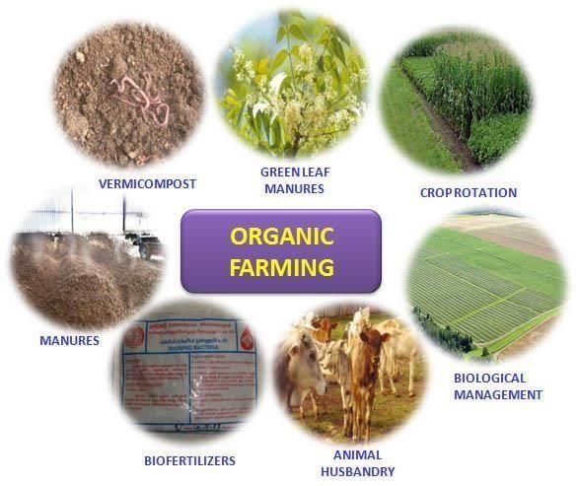
The Important Goals of Organic Farming are:
✔A Sufficiently High Level of Productivity.
- Compatibility of cultivation with the natural cycles of the production system as a whole. ✔ Maintaining and
Increasing the Long-term fertility and biological activity of the soil . ✔ Maintaining and Increasing Natural Diversity and Agro-bio diversity.
- Maximum Possible Use of Renewable resources.
- Creation of a harmonic balance between crops and animal husbandry.
- Creation of conditions in which animals are kept that correspond to their natural behavior.
- Protection of,and learning from, indigenous knowledge and traditional management system

Advantages of Organic Farming :
Organic farming has gained significant attention and popularity in recent years as people become more conscious of the impact of conventional farming methods on the environment and human health.
Organic farming prioritizes sustainability, natural practices, and the overall well-being of ecosystems. This essay explores the numerous advantages of organic farming and highlights its positive impacts on the environment, human health, and rural communities. Organic farming is an agricultural method that emphasizes the use of natural and sustainable practices to cultivate that work in harmony with nature. This approach offers numerous advantages over conventional methods, benefiting not only the environment but also human health and overall sustainability. In this article, we will explore some of the key advantages of organic farming

  - Environmental Benefits:
One of the primary advantages of organic farming is its positive impact on the environment.
Organic farmers prioritize soil health and employ practices that enhance soil fertility and structure.
They use compost, animal manure, and crop rotations to maintain soil fertility, which reduces soil erosion and helps retain moisture in the soil. By avoiding synthetic pesticides and fertilizers, organic farming minimizes water pollution and helps protect the biodiversity of ecosystems.
Organic farms also promote wildlife conservation by creating habitats for beneficial organisms like birds, bees, and beneficial insects.

  - Healthier Food:
Organic farming produces healthier and safer food compared to conventionally grown counterparts. Organic crops are grown without the use of synthetic pesticides, herbicides, or genetically modified organisms (GMOs). This means that the food grown organically has lower levels of pesticide residues, reducing the risk of pesticide exposure for consumers. Organic farming also avoids the use of antibiotics and growth hormones in livestock, ensuring that organic meat and dairy products are free from these substances. Additionally, organic crops have been found to contain higher levels of certain nutrients, such as antioxidants,which can contribute to improved health outcomes.

  - Protection of Water Resources:
Organic farming plays a crucial role in protecting water resources. Synthetic fertilizers and pesticides used in conventional farming can leach into groundwater and contaminate water bodies, leading to water pollution. Organic farming practices, on the other hand, focus on soil health and nutrient cycling, which minimize nutrient runoff and water pollution. By maintaining healthy soils and using natural pest control methods, organic farming reduces the risk of chemical contaminants entering water sources. This not only preserves water quality but also ensures the long-term availability of clean water for agricultural purposes and human consumption.

  - Long-term Sustainability:

Organic farming practices are inherently sustainable and promote long-term agricultural productivity. By prioritizing soil health and fertility, organic farmers build resilient and productive soils that can withstand climate variations and maintain high crop yields. Organic farming also encourages crop rotation, which helps break pest and disease cycles naturally, reducing the reliance on chemical pesticides. Furthermore, organic farmers promote biodiversity by creating habitats for beneficial insects, birds, and wildlife, contributing to a more balanced and sustainable
  - Supports Rural Communities:
Organic farming can play a vital role in supporting rural communities and local economies. Organic farms often employ more labor-intensive practices, creating job opportunities in rural areas. Additionally, the emphasis on local production and distribution in organic farming promotes shorter supply chains, allowing farmers to sell their produce directly to consumers or through local markets. This direct connection between farmers and consumers not only strengthens community bonds but also ensures that farmers receive a fair price for their products, thus contributing to the economic viability of rural communities

6 .Economic Benefits for Rural Communities:
Organic farming can provide economic advantages, particularly for rural communities. Organic agriculture often requires more labor-intensive practices, which can create additional employment opportunities in rural areas. Small-scale farmers, in particular, can benefit from organic certification, which enables them to access premium markets and receive higher prices for their organic products. By diversifying their production methods and adopting organic practices, farmers can also reduce their reliance on costly synthetic inputs, thus improving their profitability and sustainability in the long term
6. climate Change Mitigation:
Organic farming contributes to mitigating climate change by reducing greenhouse gas emissions and promoting carbon sequestration. Organic practices, such as organic soil management, enhance soil organic matter, which helps sequester carbon dioxide from the atmosphere. Additionally, organic
farmers minimize the use of fossil fuel-based inputs, such as synthetic fertilizers and pesticides, which reduces the carbon footprint associated with agricultural production.

CHAPTER6: RECOMMENDATIONS AND CONCLUSIONS OF THE MINIPROJECT Recommendations:
Soil Health:
Focus on improving and maintaining soil health through practices such as crop rotation, cover cropping, and composting. These practices enhance soil fertility, nutrient availability, and water holding capacity.
Pest and Disease Management:
Emphasize integrated pest management (IPM) techniques, including biological control methods, crop diversification, and the use of organic pesticides and fungicides. Regular monitoring and early detection of pests and diseases are crucial for effective management.
Nutrient Management:
Implement balanced nutrient management by conducting soil tests to determine the nutrient requirements of different crops. Utilize organic fertilizers, such as compost and manure, to replenish soil nutrients and promote healthy plant growth.
Conservation:
water Adopt water conservation practices like drip irrigation, mulching, and rainwater harvesting. These techniques minimize water wastage, reduce soil erosion, and help maintain adequate moisture levels for crops. Marketing and Certification: Explore avenues for marketing organic produce to ensure a fair price for your products. Consider obtaining organic certification to enhance consumer trust and access premium markets that prioritize organic produce
Conclusion
Organic farming works harmony with nature rather than against it. This Involves Using Techniques to achieve good crop yields without harming the natural environment or the people who live and work in it. An Organic Farmer Produces Vegetables ,fruit ,cereal crops ,or livestock without the use of chemical fertilizers, pesticides, or herbicides. In another way organic farming is a kind of agriculture that provides the consumers with fresh, tasty and reliable food while regarding natural life cycle systems. In addition to the health benefits of organic products for consumers, there are vital environmental benefits for the earth. Organic farming keeps biodiversity and reduces environmental pollution such as air, water and soil. Organic agriculture has grown out of conscious efforts by inspired people to create the best possible relationship between earth and men

Student Self-Evaluation for the Community Service Project

Student name:KOTTA SRAVANTHI
Reg no : 222H1A0494
Period of CSP : 8 weeks
From : 15-08-2024 To : 14-10-2024
Name of the person incharge : Mrs.N.Ramadevi.M tech
Adress : Vinjamoor(V) ,Vinjamoor(M), Nellore(DIST)
Phone No : 6300680785
Please rate your performance in the following areas:

Rating Scale: 1 is lowest and 5 is highest rank

1) Oral communication | 1 | 2 | 3 | 4 | 5
2) Written communication | 1 | 2 | 3 | 4 | 5
3) Pro activeness | 1 | 2 | 3 | 4 | 5
4) Interaction ability with community | 1 | 2 | 3 | 4 | 5
5) Positive Attitude | 1 | 2 | 3 | 4 | 5
6)Self-confidence | 1 | 2 | 3 | 4 | 5
7) Ability to learn | 1 | 2 | 3 | 4 | 5
8) Work Plan and organization | 1 | 2 | 3 | 4 | 5
9) Professionalism | 1 | 2 | 3 | 4 | 5
10)Creativity | 1 | 2 | 3 | 4 | 5
11)Quality of work done | 1 | 2 | 3 | 4 | 5
12)Time Management | 1 | 2 | 3 | 4 | 5
13)Understanding the Community | 1 | 2 | 3 | 4 | 5
14)Achievement of Desired Outcomes | 1 | 2 | 3 | 4 | 5
15)OVERALL PERFORMANCE | 1 | 2 | 3 | 4 | 5

Date: Signature of the Student Evaluation by the Person in-charge in the Community/Habitation
Student name : JAMPALA THARUN KUMAR
Reg no : 22H1AO478
Period of CSP : 8 weeks
From : 15-08-2024 To : 14-10-2024
Name of the person incharge : Mrs.K.GAYATHRI M tech
Adress : NAIDUPETA(V) ,NAIDUPETA(M ) ,TIRUPATI(DIST)
Phone No : 8688657784
Please rate your performance in the following areas:

Rating Scale: 1 is lowest and 5 is highest rank

1) Oral communication | 1 | 2 | 3 | 4 | 5
2) Written communication | 1 | 2 | 3 | 4 | 5
3) Pro activeness | 1 | 2 | 3 | 4 | 5
4) Interaction ability with community | 1 | 2 | 3 | 4 | 5
5) Positive Attitude | 1 | 2 | 3 | 4 | 5
6)Self-confidence | 1 | 2 | 3 | 4 | 5
7) Ability to learn | 1 | 2 | 3 | 4 | 5
8) Work Plan and organization | 1 | 2 | 3 | 4 | 5
9) Professionalism | 1 | 2 | 3 | 4 | 5
10)Creativity | 1 | 2 | 3 | 4 | 5
11)Quality of work done | 1 | 2 | 3 | 4 | 5
12)Time Management | 1 | 2 | 3 | 4 | 5
13)Understanding the Community | 1 | 2 | 3 | 4 | 5
14)Achievement of Desired Outcomes | 1 | 2 | 3 | 4 | 5
15)OVERALL PERFORMANCE | 1 | 2 | 3 | 4 | 5

Date: Signature of the Supervisor

PHOTOS AND VIDEO LINKS

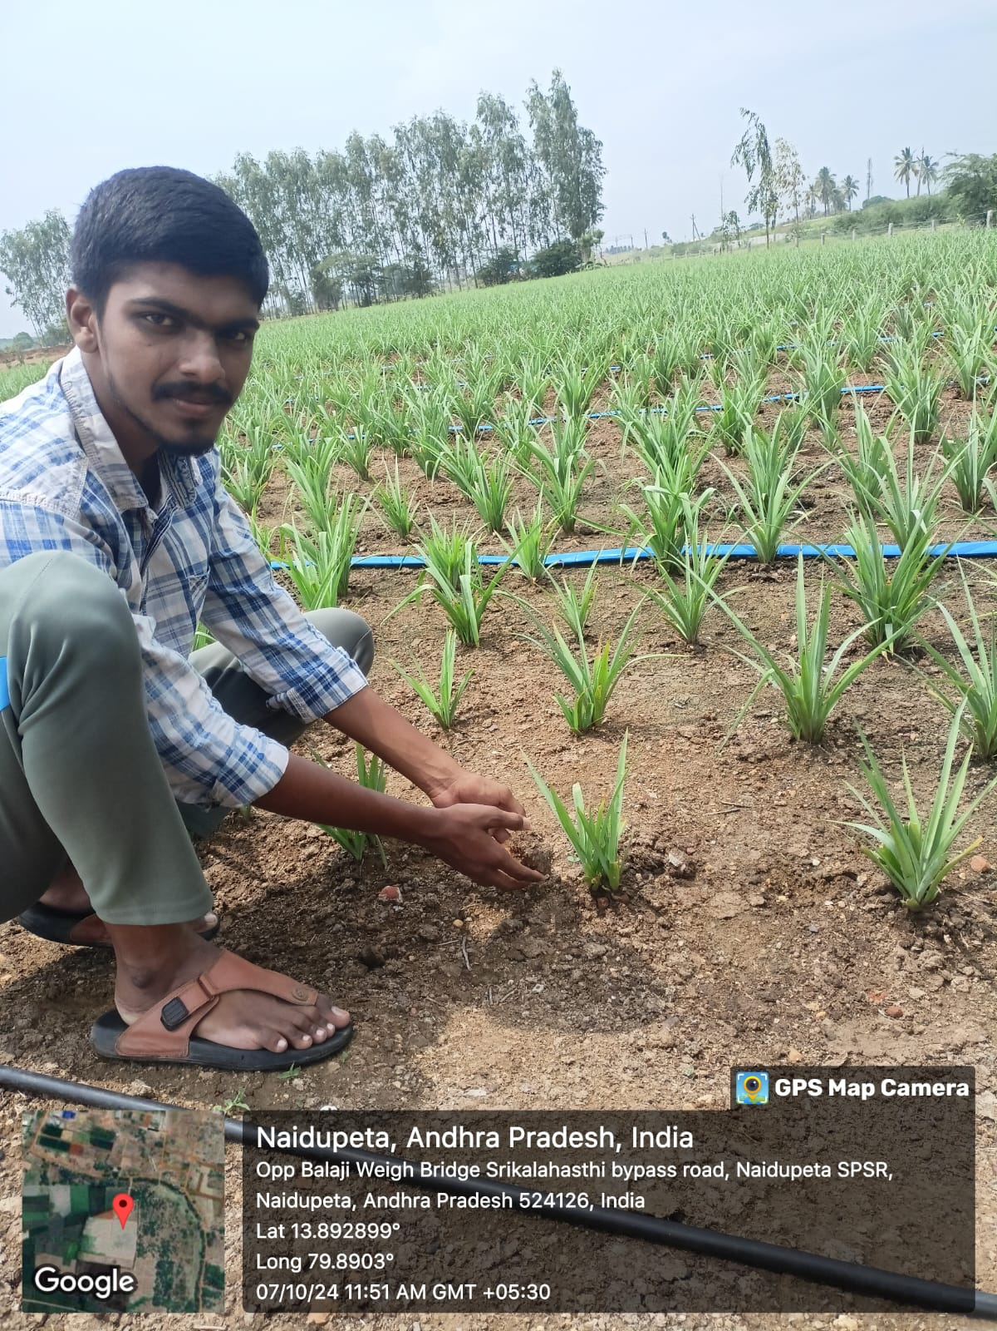

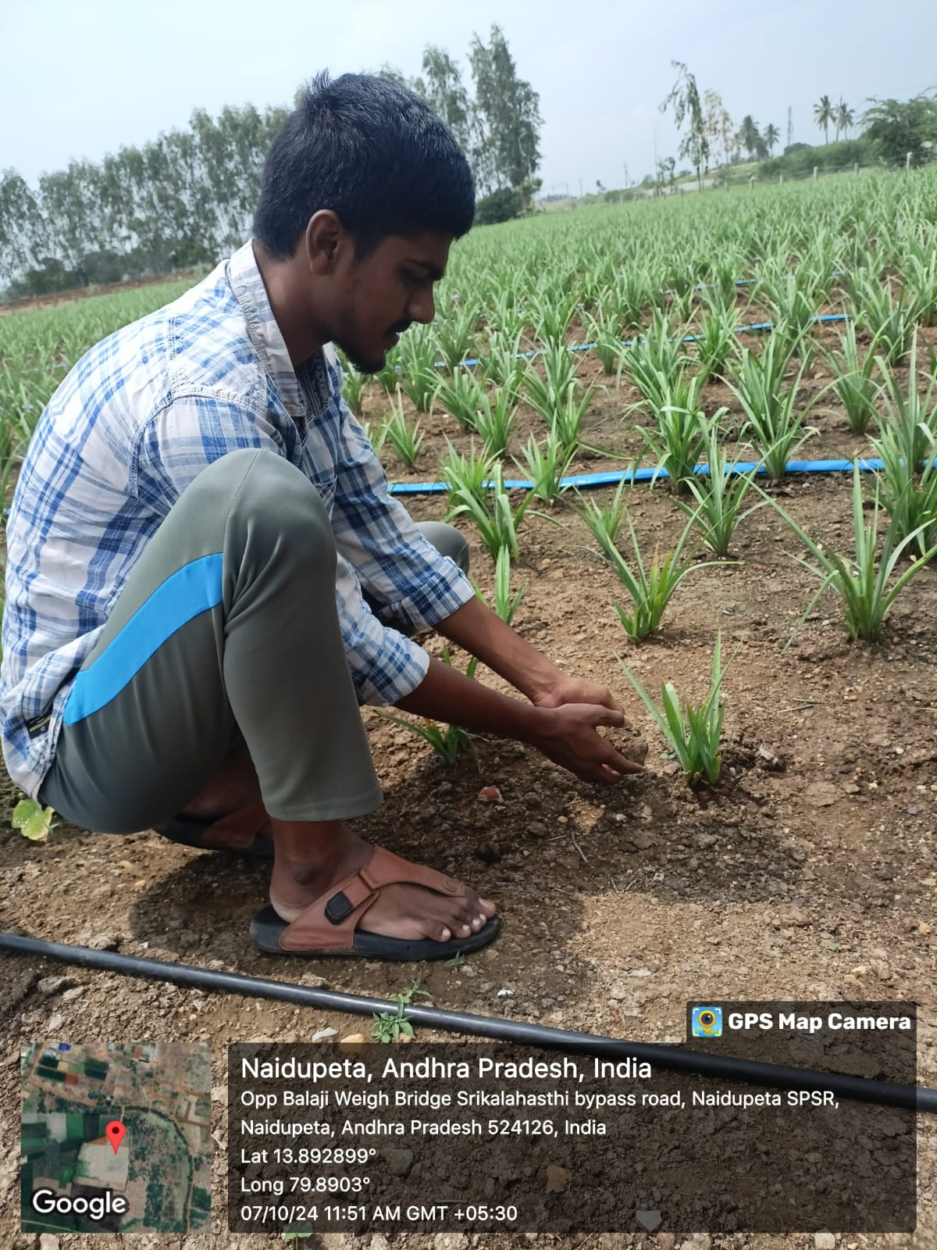


CONCLUSION:

Organic farming is an agricultural method that adheres to the principles of sustainable development. It's an agricultural production management method that does not utilize pesticides, chemical fertilizers, industrial synthetic products, or genetically modified organisms.

Organic agriculture helps reduce the use of non-renewable energy by contributing to the greenhouse effect. “A number of studies revealed that soil organic carbon contents under organic farming are considerably higher” (“Organic Agriculture”). The impact of organic agriculture on natural resources is vast.

